MENTORNESS TASK 2

NAME- ABHIJEET KUNDU

1. **Retrieve all columns for sales made in a specific branch (e.g., Branch 'A').**

**CODE-**

SELECT *

FROM walmartdata

WHERE Branch = 'A';

**OUTPUT-**

2. **Find the total sales for each product line.**

**CODE-**

SELECT Product_line, SUM(Total) AS Total_Sales

FROM wlmartdata

GROUP BY Product_line;

**OUTPUT-**

3. **List all sales transactions where the payment method was 'Cash'.**

**CODE-**

SELECT *

FROM walmartdata

WHERE Payment = 'Cash';

**OUTPUT-**

4**. Calculate the total gross income generated in each city.**

**CODE-**

SELECT City, SUM(gross_income) AS Total_Gross_Income

FROM walmartdata

GROUP BY City;

**OUTPUT-**

5. **Find the average rating given by customers in each branch.**

**CODE-**

SELECT Branch, AVG(Rating) AS Average_Rating

FROM walmartdata

GROUP BY Branch;

**OUTPUT-**

6. **Determine the total quantity of each product line sold.**

**CODE-**

SELECT Product_line, SUM(Quantity) AS Total_Quantity

FROM walmartdata

GROUP BY Product_line;

**OUTPUT-**

7. **List the top 5 products by unit price.**

**CODE-**

SELECT *

FROM walmartdata

ORDER BY Unit_price DESC

LIMIT 5;

**OUTPUT-**

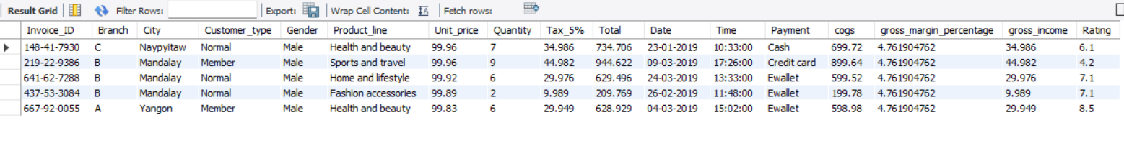

8. **Find sales transactions with a gross income greater than 30.**

**CODE-**

SELECT *

FROM walmartdata

WHERE gross_income > 30;

**OUTPUT-**

9. Retrieve sales transactions that occurred on weekends.

**CODE-**

SELECT *

FROM walmartdata

WHERE DAYOFWEEK(Date) IN (5, 6);

**OUTPUT-**

10. **Calculate the total sales and gross income for each month.**

**CODE-**

SELECT DATE_FORMAT(Date, '%Y-%m') AS Month, SUM(Total) AS Total_Sales, SUM(gross_income) AS Total_Gross_Income

FROM walmartdata

GROUP BY DATE_FORMAT(Date, '%Y-%m');

**OUTPUT-**

11. **Find the number of sales transactions that occurred after 6 PM.**

**CODE-**

SELECT COUNT(*) AS Sales_After_6_PM

FROM walmartdata

WHERE TIME(Time) > '18:00:00';

**OUTPUT-**

12. **List the sales transactions that have a higher total than the average total of all transactions.**

**CODE-**

SELECT *

FROM walmartdata

WHERE Total > (SELECT AVG(Total) FROM walmartdata);

**OUTPUT-**

13. **Calculate the cumulative gross income for each branch by date.**

**CODE-**

SELECT Date, Branch, SUM(gross_income) OVER (PARTITION BY Branch ORDER BY Date) AS Cumulative_Gross_Income

FROM walmartdata;

**OUTPUT-**

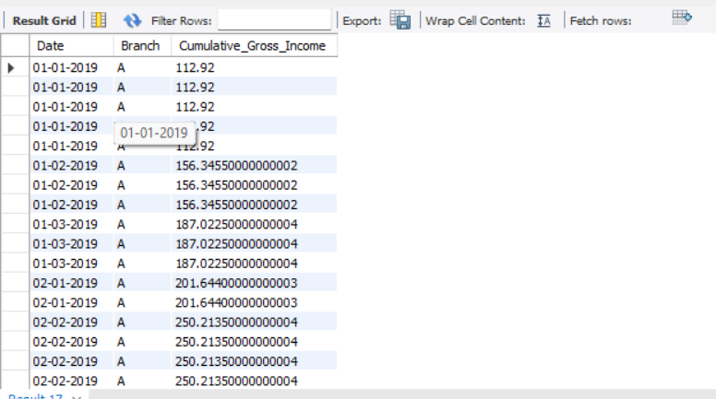

15. **Find the total cogs for each customer type in each city.**

**CODE-**

SELECT City, Customer_type, SUM(cogs) AS Total_COGS

FROM walmartdata

GROUP BY City, Customer_type;

**OUTPUT-**

